CODE:

import random

i=1

while(i<=7):

a=random.randint(20,200)

b=random.randint(20,100)

print(f'Day {i}')

print(f'Temperature:{a} )

print(f'Humidity :{b} )

if a>80:

if b>80:

print("HAZARD PREDICTED... ")

else:

print("HIGH TEMPERATURE ")

elif a==80:

print("TEMPERATURE HIGH ")

else:

print("ALL GOOD ")

i=i+1

print(end="\n")

OUTPUT 1

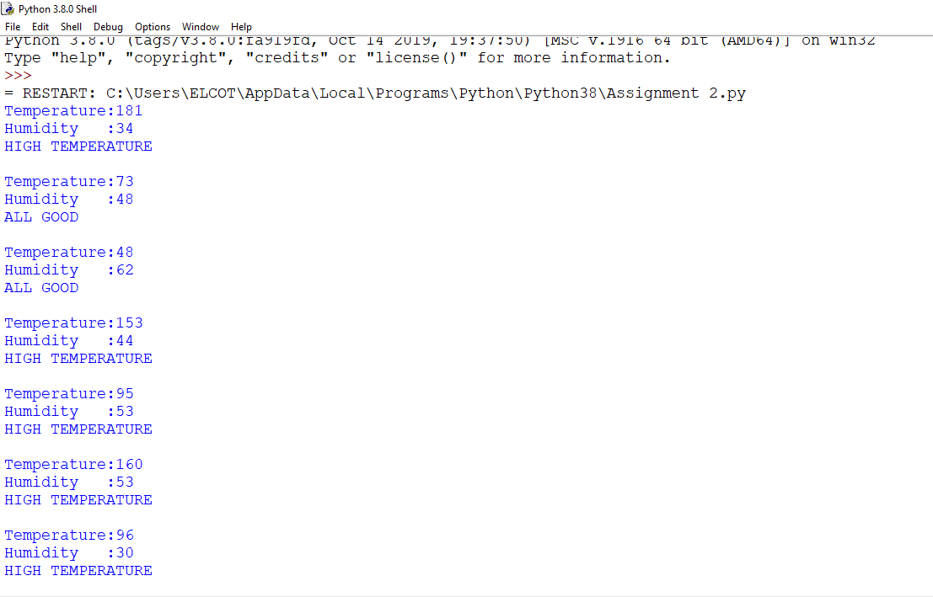

OUTPUT 2

